PRODUCT MARKETING & BUSINESS STRATEGY
CASE STUDY

Apple Vision Pro
A Complete Product Marketing and Business Strategy Case Study
Prepared as an independent strategic analysis
for portfolio and professional review purposes
July 2026
Strategy · Market Research · Competitive Analysis · Positioning · Go-to-Market

Executive Summary
Apple Vision Pro entered the market in February 2024 as Apple's first entirely new product category since the Apple Watch, and its most expensive consumer device to date. Marketed as a spatial computer rather than a headset, it combined Apple's design language, silicon expertise, and software ecosystem with an unproven and historically difficult category: head-worn computing. This report examines Vision Pro through the lens of product marketing and business strategy, evaluating how Apple positioned the product, who it was built for, how it competes, and where the platform is heading as of mid-2026.
Two and a half years after launch, the picture is mixed but instructive. Vision Pro has not achieved mass-market adoption, and Apple itself appears to have recalibrated its ambitions. The company refreshed the device with an M5 chip in October 2025 rather than releasing a true second generation, paused active development of a successor for at least two years, and in June 2026 raised prices across the lineup to between 3,699 and 4,199 dollars, a move industry analysts read as a signal that Apple has largely accepted the product's current role as a professional and enterprise instrument rather than a mainstream consumer device. At the same time, Vision Pro has found genuine traction in specific verticals, including pilot training, surgical education, product design review, and enterprise collaboration, where organizations value its display quality and spatial precision enough to absorb its price.
This case study argues that Vision Pro is best understood not as a failed consumer product but as a deliberately premium, technology-forward platform that is still searching for its durable market position. Apple used the first generation to establish the technical foundation, visionOS, and a developer ecosystem, while pricing and weight kept volume low by design. The strategic question for Apple's leadership is no longer whether Vision Pro was a good idea in principle, but whether the company should now pursue a lower-cost consumer variant, double down on enterprise and professional use cases, or hold the line and wait for component costs and battery technology to mature.
The analysis that follows covers Apple's broader strategic context, the evolution of spatial computing as a category, Vision Pro's target audience and customer journey, its pricing and business model, a detailed competitive comparison against Meta Quest, Microsoft HoloLens, Magic Leap, and XREAL, a SWOT assessment, industry-specific use cases, and a set of strategic recommendations for Apple's leadership team. Where public data is unavailable, this report says so explicitly rather than estimating figures Apple has not disclosed.

Table of Contents
The listing below reflects the section structure of this report. In Microsoft Word, right-click the table below and select "Update Field" to generate live page numbers and hyperlinks.

Introduction
Every few years, a product arrives that forces an entire industry to re-examine what a computer can be. The mouse did it. The smartphone did it twice, first with the iPhone and again as it globalized the internet. Apple Vision Pro is Apple's attempt to do it a third time, this time by moving computing off the desk and off the palm and directly into the user's field of view. Apple calls this spatial computing: the blending of digital content and the physical environment through a headset that tracks the eyes, hands, and surroundings in real time.
This report treats Vision Pro as a business and marketing case rather than a technology review. It asks the questions an executive team would ask two and a half years into a bold, capital-intensive bet: who actually bought this product, why did they buy it, what job is it doing for them, how does it compare with the alternatives, and what should the company do next. The report draws on Apple's own public materials, independent market research, and reporting from technology and business press through July 2026. It does not speculate about unannounced products beyond what has been credibly reported, and it flags uncertainty wherever Apple has not disclosed hard figures such as unit sales.
The intended reader is a hiring manager, product marketing leader, or business strategist evaluating this document as a portfolio piece. Accordingly, the report favors structured analysis, comparison, and reasoned recommendation over promotional language. Vision Pro is a genuinely impressive piece of engineering, and it is also a product with real limitations and an unresolved path to scale. Both things are true, and both are addressed here.

Apple Company Background
Apple is the world's most valuable consumer technology company by market capitalization for much of the past decade, built on a tightly integrated model that pairs its own silicon, operating systems, and industrial design with a services and App Store ecosystem that keeps customers inside its platform. The company's core revenue still comes overwhelmingly from the iPhone, supplemented by Mac, iPad, wearables, and a fast-growing Services segment that includes the App Store, Apple Music, iCloud, and Apple TV+.
Apple's product strategy has historically followed a consistent pattern: enter a category later than pioneers, but enter with tighter integration between hardware, software, and silicon than competitors can match, then use that integration to justify a premium price. This played out with the iPod against earlier MP3 players, the iPhone against Windows Mobile and BlackBerry, and the iPad against earlier tablet attempts. Vision Pro follows the same playbook in spatial computing, arriving years after Oculus, HTC, and Microsoft had already shipped headsets, but wrapping the category in Apple's silicon advantage, its App Store distribution, and its brand equity for premium design.
Under Tim Cook, Apple has increasingly framed new hardware as a platform investment rather than a standalone product. Vision Pro fits this framing: it is as much a bet on the long-term category of spatial computing, and on visionOS as a software platform for that category, as it is a bet on this specific first-generation headset selling in high volume. Cook's planned transition of the CEO role to John Ternus, reported in industry coverage through 2026, has coincided with a consolidation of Apple's headset and smart glasses efforts, suggesting the company's spatial computing strategy is entering a second, more focused phase.

Evolution of Spatial Computing
Head-worn computing has moved through three distinct waves. The first wave, roughly 2012 to 2016, was defined by early virtual reality pioneers such as the Oculus Rift, HTC Vive, and Google Cardboard. These devices proved that immersive, tracked, stereoscopic displays were technically possible, but they were tethered to PCs, uncomfortable, and limited to niche gaming and research audiences.
The second wave, roughly 2016 to 2022, shifted toward standalone and enterprise-focused devices. Microsoft's HoloLens introduced see-through augmented reality for industrial and military applications, while Meta's Quest line, beginning with the original Oculus Quest in 2019, proved that a standalone, wireless, reasonably priced headset could reach a genuine consumer audience, primarily gamers. Magic Leap attempted a consumer AR launch in 2018, failed to find product-market fit, and pivoted to enterprise with Magic Leap 2 in 2022.
The third wave, which Vision Pro opened in February 2024, is defined by high-resolution passthrough mixed reality, where cameras feed a live video view of the physical world into the headset rather than using see-through optics, combined with eye and hand tracking as the primary input method instead of handheld controllers. This approach trades some of the optical elegance of true see-through AR for dramatically higher resolution, better color fidelity, and a more natural interaction model. Meta followed a similar passthrough approach with Quest 3, launched a few months before Vision Pro at a fraction of the price, setting up the direct rivalry this report examines in the competitive analysis section.
As of 2026, the category is bifurcating further. Display-based mixed reality headsets like Vision Pro and Quest are being joined by a fast-growing segment of display-less smart glasses, exemplified by Meta's Ray-Ban partnership, which prioritize social acceptability, all-day wearability, and AI assistance over full immersion. Industry data from IDC indicates smart glasses shipments grew sharply in early 2026, even as the more immersive mixed reality segment Vision Pro competes in remains smaller and slower to scale. This bifurcation matters strategically because it suggests the eventual mass-market winner in head-worn computing may look more like glasses than like a headset, a possibility Apple itself appears to be hedging against with reported work on a separate smart glasses product.

What is Apple Vision Pro
Apple Vision Pro is a standalone, wireless mixed-reality headset that Apple describes as a spatial computer. Rather than positioning it as a gaming or virtual reality device, Apple frames Vision Pro as a general-purpose computing platform, similar in ambition to the Mac or iPad, that happens to be worn on the face. It runs visionOS, a purpose-built operating system derived from Apple's existing platforms, and it is controlled primarily through eye tracking for pointing and hand gestures for selection, with no handheld controller required.
The device uses passthrough video from an array of outward-facing cameras to blend live footage of the user's physical environment with digital windows, objects, and 3D content, a mode Apple calls mixed reality. A digital crown lets users dial between fully immersive virtual environments and a passthrough view of the real world. An external display called EyeSight projects a rendering of the user's eyes outward, an attempt to reduce the social isolation that headsets typically create.

Product Overview
The current Vision Pro, refreshed with Apple's M5 chip in October 2025, pairs the M5 for general app processing with Apple's dedicated R1 chip, which handles real-time sensor fusion from twelve or more cameras, LiDAR, and motion sensors at low latency to prevent motion sickness. Two custom micro-OLED displays deliver over twenty million combined pixels, and the M5 refresh increased rendered pixel density by roughly ten percent over the original M2 model according to Apple's own materials. Battery life is rated at up to two and a half hours of general use from an external battery pack, or up to three hours of video playback, a figure that remains one of the device's most cited limitations.
Physically, Vision Pro resembles a pair of ski goggles: a single curved laminated glass front is set into an aluminum alloy frame, with a soft Light Seal that conforms to the user's face and a knitted headband, now available as a Dual Knit Band that distributes weight over the top of the head as well as around it. At roughly 1.3 pounds for the headset alone, plus a tethered battery pack, weight and comfort during extended sessions remain a common complaint in reviews. Storage options span 256GB, 512GB, and 1TB, and buyers who need vision correction can add magnetically attached ZEISS Optical Inserts.

Core Hardware Specifications
Attribute | Detail
Chip | Apple M5 (main), Apple R1 (real-time sensor processing)
Displays | Dual micro-OLED, over 20 million combined pixels
Battery life | Up to 2.5 hours general use, up to 3 hours video, via external pack
Weight | Approximately 600-650g headset, plus external battery
Input | Eye tracking, hand gesture tracking, voice via Siri
Storage options | 256GB / 512GB / 1TB
Operating system | visionOS (visionOS 27 in beta as of mid-2026)
Audio | Spatial Audio via dual Audio Straps integrated into the headband
Table 1. Apple Vision Pro (M5) core specifications, compiled from Apple Newsroom and Apple's product pages.
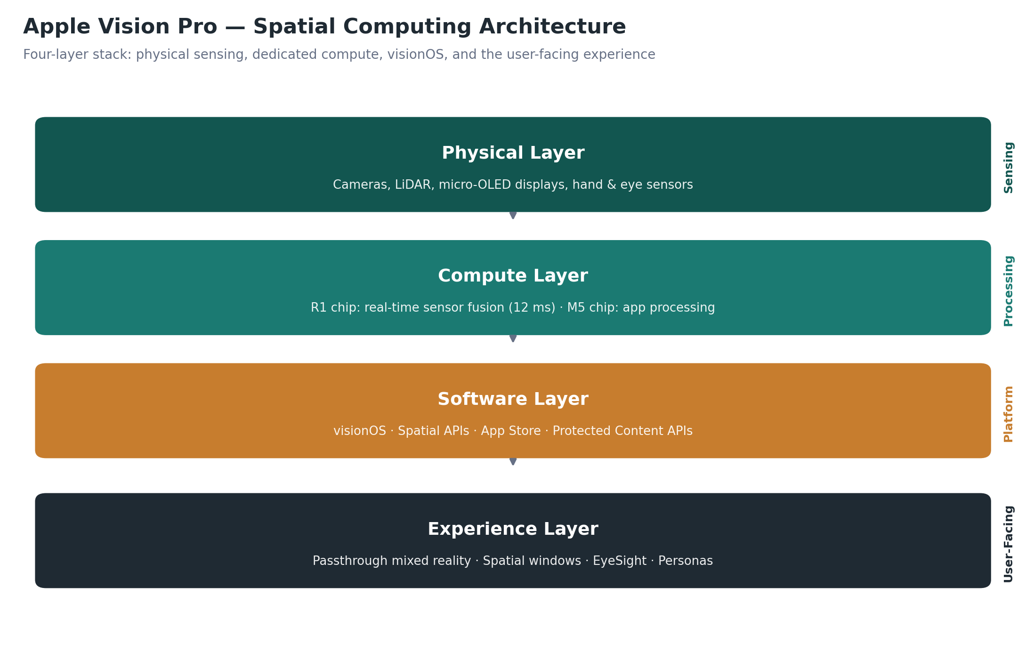
Figure 1. The Vision Pro stack layers physical sensing, dedicated compute, visionOS, and the user-facing experience.

Market Opportunity
The broader extended reality market, encompassing virtual reality, augmented reality, and mixed reality hardware and software, has been forecast by multiple research firms to grow substantially through the end of the decade, driven less by gaming than by enterprise training, design, healthcare, and, increasingly, AI-enabled smart glasses. Within that broader category, industry analyst IDC has estimated that the mixed reality segment closer to Vision Pro's own positioning was on a growth path from roughly 3.2 million units in 2026 toward approximately 10.4 million units by 2030, a meaningful expansion but still a fraction of the volume that categories like smartphones or even tablets achieve in a single quarter.
Apple does not disclose Vision Pro unit sales, and this report does not estimate a specific figure Apple has not confirmed. What public reporting does indicate consistently is that Vision Pro holds a small single-digit share of the broader XR hardware market, commonly cited in analyst commentary as being in the mid single digits, against Meta's dominant share of the same category. That gap is a direct function of price: Vision Pro starts at roughly seven to eight times the price of Meta's mainstream headsets, which mechanically narrows its addressable buyer pool to a wealthier, more professionally motivated segment.
The more interesting opportunity for Apple may not be the consumer mixed reality market at all, but the enterprise and professional segment, where the total addressable spend is smaller in unit terms but far less price-sensitive. Organizations evaluating Vision Pro compare its cost not against a game console but against the cost of flight simulator time, surgical training cadavers, physical prototypes, or business travel, a comparison in which a four-thousand-dollar headset can look inexpensive rather than prohibitive. This reframing, explored further in the industry use cases section, is central to how this report interprets Apple's 2026 pricing decisions.

Industry Trends
Several trends define the spatial computing landscape Vision Pro competes in during 2026. First, component costs are rising rather than falling. Apple, Meta, and other manufacturers raised prices on existing headset hardware in the first half of 2026, citing a global surge in memory and storage chip costs driven largely by demand from AI data centers. This is a meaningful departure from the usual consumer electronics pattern of falling prices over a product's life, and it complicates any strategy premised on Vision Pro eventually becoming cheaper through simple component maturation.
Second, the center of gravity in consumer XR is shifting toward lightweight, display-less smart glasses rather than fully immersive headsets. Meta's Ray-Ban partnership has captured the large majority of this fast-growing segment, and reported shipment growth for smart glasses in early 2026 significantly outpaced growth in mixed reality headsets. Third, enterprise adoption of mixed reality is real but uneven: pilots in training, healthcare, and design review are converting into paid deployments at select organizations, but broad workforce-scale rollouts remain the exception rather than the rule across the industry, a pattern consistent with earlier waves of enterprise AR adoption on devices like HoloLens 2.
Fourth, developer investment in native spatial applications remains thin relative to Apple's other platforms. Reporting drawing on Apple's own submission data suggests visionOS receives a very small fraction of the native app submissions that iOS or iPadOS attract on a daily basis, even though Apple has cited over a million compatible apps available through iPad app compatibility. This gap between available apps and apps built specifically to take advantage of spatial computing is one of the more persistent structural challenges facing the platform, and it is a theme this report returns to in the risks and recommendations sections.

Target Audience
Vision Pro's realistic addressable audience splits into three groups rather than one. The first is early-adopter enthusiasts and existing Apple loyalists with high discretionary income, drawn to being first with Apple's most ambitious new category in years. The second is media, design, and knowledge-work professionals who use Vision Pro as a large, private, portable display for productivity and content review, effectively treating it as a Mac accessory as much as a headset in its own right. The third, and increasingly the most commercially significant, is enterprise buyers purchasing on behalf of specific functions, including training, healthcare, design, and aviation, where a procurement team rather than an individual consumer makes the buying decision.
It is worth stating plainly what Vision Pro's target audience is not: it is not, at current pricing, a mass-market device aimed at the same buyer who purchases a Meta Quest for gaming. Apple's own marketing, distribution through appointment-based Apple Store demos rather than mass retail, and pricing all point toward a deliberately narrow initial audience, with mass-market appeal treated as a future-generation ambition rather than a current-generation goal.

Customer Personas
The three personas below are illustrative composites built from patterns described in independent reviews, enterprise case coverage, and Apple's own marketing narratives. They are not drawn from Apple-disclosed customer data, which Apple does not publish.

Persona 1: The Creative Early Adopter
Represents a designer, filmmaker, or product photographer in their thirties or forties, already embedded in Apple's ecosystem across Mac, iPhone, and iPad. Buys Vision Pro to review spatial video and 3D content, to work across an expansive virtual desktop, and to experiment with spatial content creation for clients. Price-sensitive in principle but treats the purchase as a professional tool and a creative instrument rather than a toy, and is willing to justify the cost against freelance billing rates.

Persona 2: The Enterprise Training Lead
Represents a learning and development or simulation manager at a large organization in aviation, healthcare, or manufacturing, evaluating Vision Pro alongside HoloLens 2 and Varjo for a formal training or design-review deployment. Cares about content authoring tools, device management, data security, and measurable outcomes such as training time reduction, not about entertainment features. Procures in bulk through Apple's enterprise channel rather than a retail Apple Store, and compares total cost against simulator time or physical prototyping costs rather than against a consumer headset.

Persona 3: The Home Theater and Productivity Enthusiast
Represents an affluent professional who travels frequently and wants a private, large-format entertainment and productivity screen that fits in a bag. Uses Vision Pro primarily for watching video during flights using Travel Mode, for video calls with a Persona avatar, and as an extended Mac display. Less interested in spatial computing as a paradigm shift and more interested in the device as a premium personal cinema and second monitor, a use case Apple has actively marketed.

Customer Journey
Apple designs the Vision Pro purchase path deliberately around education and hands-on demonstration rather than impulse buying, reflecting both the product's price and its unfamiliar interaction model. The journey typically unfolds in five stages, summarized in the diagram and table below.
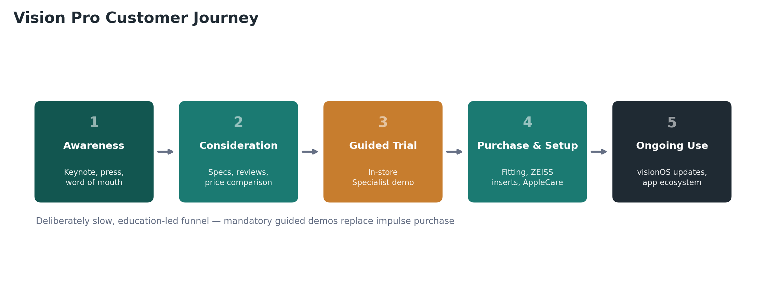
Figure 2. The five-stage Vision Pro customer journey, from awareness to ongoing use.
Stage | Customer Activity | Apple's Role
1. Awareness | Learns about Vision Pro through Apple keynotes, press coverage, or word of mouth | Keynote positioning as a new category; controlled press narrative
2. Consideration | Researches specs, reviews, and price versus alternatives such as Quest 3 | Detailed product pages; comparison content; vision-correction guidance
3. Guided Trial | Books a one-on-one in-store demo, since impulse purchase is discouraged | Apple Store Specialist-led demo; fit and vision assessment
4. Purchase & Setup | Orders online or in-store; completes ZEISS insert and Light Seal fitting if needed | Personalized fitting process; AppleCare and financing options
5. Ongoing Use | Integrates device into work, travel, or entertainment routines; upgrades apps | visionOS updates; App Store content; Apple ecosystem integration
Table 2. Vision Pro's guided customer journey, from awareness through ongoing use.
The mandatory, appointment-based in-store demo is itself a strategic choice worth noting. It slows the sales funnel deliberately, but it also protects Apple from the return and dissatisfaction rates that come with an unfamiliar and expensive device sold sight unseen. It functions as both a sales tool and an expectation-setting mechanism, letting Apple address the fit, vision-correction, and comfort questions that most often cause post-purchase regret before money changes hands.

Business Problems Solved
For individual buyers, Vision Pro addresses a narrower set of problems than its marketing sometimes implies. It replaces a large external display for people who work across multiple virtual monitors, particularly for existing Mac users who want more screen space while traveling or in small living spaces. It provides a private, immersive entertainment environment that a phone or tablet screen cannot match, which is central to Apple's travel and airline partnership marketing. It also offers a presence-based video calling experience through Persona avatars, aimed at remote workers who want more expressive video meetings than a webcam provides.
For enterprise buyers, the problems are more concrete and more defensible economically. Vision Pro can reduce the cost and risk of physical prototyping by letting design and engineering teams review 3D models at true scale before committing to tooling, a use case reported at companies such as Porsche. It can compress training time in high-stakes fields such as aviation, with CAE reporting meaningfully faster certification completion using Vision Pro-based training modules. It can support remote clinical decision-making and surgical training without the scheduling and logistical cost of physical simulation labs, an application several medical technology companies have pursued.

Product Features

Headline Software and Experience Features
Feature | What It Does | Primary Beneficiary
visionOS spatial windows | Lets users open and arrange multiple resizable app windows in 3D space | Productivity users, multitaskers
Passthrough Mixed Reality | Blends live camera video of the room with digital content in real time | All users; foundation of the platform
Eye and hand tracking input | Enables pointing with the eyes and selecting with a pinch, no controller needed | All users; core interaction model
EyeSight external display | Shows an approximation of the user's eyes to people nearby | Bystanders; reduces social isolation
Personas | Digital avatar of the user for video calls and FaceTime | Remote workers, hybrid teams
Spatial video and photos | Captures and replays 3D, immersive photos and video | Consumers, families, content creators
Mac Virtual Display | Extends a connected Mac's screen into an ultra-wide virtual monitor | Mac-based professionals
Travel Mode | Adapts tracking and stability for use on airplanes and trains | Frequent travelers
Protected Content APIs | Gates regulated or sensitive data by user role for enterprise use | Enterprise IT and compliance teams
Table 3. Selected visionOS and Vision Pro feature set, compiled from Apple Newsroom and product documentation.
Two features deserve particular strategic note. Protected Content APIs and persistent, role-based windows, both introduced through visionOS updates since launch, signal Apple's deliberate build-out of enterprise-grade functionality well beyond what a consumer entertainment device would require, reinforcing the professional-instrument positioning this report returns to throughout. Meanwhile, Mac Virtual Display and Travel Mode reveal Apple's pragmatic acknowledgment that, absent a dense native app catalog, the most reliable value driver for many buyers is simply extending devices and habits they already have.

Product Positioning
Apple positions Vision Pro explicitly against the category conventions of virtual reality rather than within them. Where competitors market headsets around gaming and immersion, Apple's language, spatial computer rather than headset or VR device, invites comparison to the Mac and iPad instead of to the Quest or PlayStation VR2. This is a classic category-repositioning move: rather than compete on the terms VR incumbents had already defined, terms on which Apple entered late and priced high, Apple redefined the terms of comparison around computing power, display fidelity, and ecosystem integration, dimensions on which it holds a genuine advantage.
The positioning carries real trade-offs. It elevates Vision Pro above gaming-centric criticism, since Apple never claimed gaming leadership, but it also invites a more demanding comparison against general-purpose computers on cost-per-use and everyday utility, a comparison the current battery life and app catalog do not yet fully support. As the earlier sections on industry trends and market opportunity suggest, Apple's 2025 and 2026 product decisions indicate the company has begun quietly shifting Vision Pro's de facto positioning further still, from a consumer spatial computer toward a professional and enterprise instrument, even as its public marketing language has changed only modestly.

Unique Value Proposition
Vision Pro's unique value proposition rests on three pillars that, taken together, no single competitor matches simultaneously: display fidelity that exceeds every mixed reality competitor on the market, an interaction model built entirely around natural eye and hand input rather than handheld controllers, and deep integration with the Apple ecosystem that lets the device extend, rather than replace, hardware and habits users already have. Meta and other rivals can match Apple on price or on raw specifications in isolation, but none currently combines Apple's display quality, software polish, and ecosystem lock-in within one device.
The counterpart to this proposition is that its value is most fully realized by people already inside the Apple ecosystem and willing to pay a substantial premium for polish and integration over raw value. For a buyer without a Mac, an iPhone, and a tolerance for premium pricing, the unique value proposition weakens considerably, which is precisely why Apple's target audience, discussed earlier, remains narrow by design rather than by accident.

Pricing Strategy
Vision Pro launched in February 2024 at 3,499 dollars for the base 256GB configuration, roughly seven times the price of Meta's flagship consumer headset at the time. Apple held that price through the October 2025 M5 refresh, an unusual choice given that Apple typically raises specifications without raising price at a mid-cycle update. That changed in June 2026, when Apple raised prices across nearly its entire hardware lineup, including Vision Pro, which moved to 3,699 dollars for 256GB, 3,899 dollars for 512GB, and 4,199 dollars for 1TB. Apple's outgoing CEO Tim Cook attributed the increases directly to a global surge in memory and storage chip costs, a pressure affecting the entire consumer electronics industry rather than Vision Pro specifically.
Configuration | Price Before June 2026 | Price From June 2026
256GB | $3,499 | $3,699
512GB | $3,699 | $3,899
1TB | $3,899 | $4,199
Table 4. Apple Vision Pro (M5) US pricing before and after the June 2026 increase. Source: Apple Newsroom, MacRumors, UploadVR.
From a pricing-strategy standpoint, this is best read as premium, value-based pricing aimed at a segment for whom price sensitivity is low, rather than penetration pricing aimed at building volume. Analysts covering the June 2026 increase argued that a 200 to 300 dollar move would have almost no effect on demand precisely because the buyers still purchasing Vision Pro at this stage of its lifecycle are enterprise and professional buyers evaluating it against capital equipment costs, not consumers comparing it to a 499-dollar Quest. Holding price steady through the M5 refresh, then raising it only when forced by input costs, also protects the brand's perceived exclusivity, a lever Apple has used deliberately across its product history.

Business Model
Vision Pro follows Apple's familiar hardware-plus-services model, but with the services layer still under construction. Direct revenue comes from hardware sales, AppleCare+ coverage, and accessories such as additional Light Seals, travel cases, and ZEISS Optical Inserts. Indirect revenue comes from the App Store's commission on paid apps and in-app purchases within the visionOS catalog, though this remains a small contributor given the platform's limited native app base relative to iOS.
Unlike the iPhone, where Apple can rely on a two-year upgrade cycle and a mature accessory and services ecosystem to generate recurring revenue, Vision Pro's business model today is closer to a strategic platform investment than a mature profit center. Apple has not disclosed Vision Pro's margin structure or profitability, and independent estimates suggest the bill of materials for a device with dual micro-OLED displays and custom silicon is substantial, meaning near-term margins are likely thinner than on Apple's higher-volume products. The more durable value Apple is likely capturing is ecosystem lock-in among a wealthy, technically engaged customer base, plus early leadership in a category Apple believes will matter over the next decade.

Marketing Strategy
Apple's Vision Pro marketing leans heavily on demonstration over description, a reasonable response to a product whose core value, presence and immersion, is difficult to convey through a screen. Launch marketing centered on long-form product videos, developer and press hands-on sessions ahead of release, and prominent keynote placement rather than a traditional broad-reach advertising campaign. Apple also invested in visible partnerships, including with airlines for in-flight Travel Mode demonstrations and with the NBA, Disney, and other content partners to showcase immersive video.
A second consistent theme in Apple's messaging is normalization of a fundamentally unusual product category. Marketing materials go out of their way to show Vision Pro used in ordinary settings, on a couch, on a plane, in a home office, rather than in futuristic or gaming contexts, an attempt to counter the perception that headsets are inherently niche or isolating. The EyeSight feature exists as much for marketing and social acceptability reasons as for genuine utility, addressing the common objection that headset wearers appear cut off from people around them.
As the product has matured, marketing emphasis has shifted from broad category evangelism toward more specific, credible use-case storytelling: enterprise customer stories in aviation and healthcare, productivity-focused messaging around Mac Virtual Display, and travel-oriented content. This shift mirrors the audience narrowing described earlier and suggests Apple's marketing organization has adapted its message to the buyers actually converting, rather than continuing to market broadly against evidence of who is buying.

Go To Market Strategy
Apple's go-to-market approach for Vision Pro was intentionally slow and controlled compared to the company's typical global-day-one launches. The device launched first in the United States in February 2024, with international markets added in phases through 2024, a rollout pace far more cautious than the simultaneous global launches Apple uses for iPhone. This staged approach let Apple manage the operational complexity of appointment-based fittings and demos market by market, and it limited the company's exposure if early demand or reviews disappointed.
Enterprise go-to-market has run on a largely separate track from consumer, built through direct engagement with large organizations, systems integrators, and named case studies, echoing how Apple has approached enterprise iPad and Mac adoption in the past. Apple has published or supported case narratives involving CAE for pilot training, Porsche for design review, SAP for internal deployment at roughly a hundred units, and several medical technology firms for clinical and surgical applications, using these as reference stories to pursue further enterprise sales rather than relying on a self-serve enterprise storefront.

Sales Strategy
On the consumer side, Apple sells Vision Pro almost exclusively through its own channels, Apple Retail Stores and apple.com, rather than through third-party electronics retailers, at least during the period covered by this report. This keeps control of the sales experience, particularly the mandatory vision assessment and fitting process, inside Apple's own environment, and it protects the brand from discount pricing or bundling by third parties that could undercut the premium positioning.
On the enterprise side, Apple's sales motion for Vision Pro resembles its broader enterprise strategy for Mac and iPad: a mix of direct account engagement from Apple's enterprise sales teams and partnerships with resellers, systems integrators, and software partners who build vertical-specific applications on top of visionOS. Financing and AppleCare One, an insurance-style program that can extend coverage across a customer's device fleet, help offset sticker-price objections for both high-income consumers and enterprise procurement teams evaluating total cost of ownership.

Distribution Channels
Vision Pro's distribution footprint remains narrower than any other current Apple product line. It is sold directly through Apple Retail Stores in a limited set of countries, through apple.com with the same appointment-based fitting process replicated over video consultation, and through Apple's enterprise sales channel for bulk organizational purchases. Unlike iPhone or Mac, Vision Pro has not been broadly distributed through third-party carriers or big-box electronics retailers, a deliberate constraint tied to the complexity of vision correction and fitting rather than a simple channel oversight.
This distribution model trades reach for control and experience quality, consistent with the guided customer journey discussed earlier. It also means Vision Pro's addressable market is smaller than its technical availability might suggest, since even an interested buyer outside Apple's launch countries, or without convenient access to an Apple Store, faces real friction in completing a purchase.

Competitive Analysis
Vision Pro competes in a fragmented landscape where rivals have made very different strategic choices about price, positioning, and target buyer. The comparison below draws on each company's current public pricing and positioning as of mid-2026 and should be read with the caveat that this is a fast-moving category; Meta's next-generation Quest, for instance, had not shipped as of this writing, with credible reporting placing a launch no earlier than late 2027.

Apple Vision Pro vs. Meta Quest
Meta Quest remains Vision Pro's most direct rival in the mixed reality headset category and the clear volume leader, commonly cited as holding roughly three-quarters of the broader XR hardware market against Vision Pro's mid-single-digit share. The current Quest lineup, Quest 3 and Quest 3S, is priced dramatically lower than Vision Pro, though Meta itself raised prices in April 2026, also citing memory chip costs, pushing the Quest 3S 128GB to 349.99 dollars and the Quest 3 512GB to 599.99 dollars. Meta's strategy has long relied on subsidizing hardware to build a large installed base for its Horizon OS platform and advertising-adjacent business, a subsidy model Apple has never used and structurally cannot replicate given its margin-driven business model.

Apple Vision Pro vs. Microsoft HoloLens
Microsoft has effectively exited the first-party mixed reality headset hardware business. HoloLens 2 production ended in 2024, and Microsoft confirmed in 2025 that it would not build a HoloLens 3, shifting its focus to cloud, AI, and software, while its military IVAS program moved to defense contractor Anduril Industries. Microsoft continues limited software and security support for existing HoloLens 2 deployments through 2027, but it is no longer a hardware competitor in any forward-looking sense. This removes what had been the most credible enterprise-native rival to Vision Pro in industrial and defense-adjacent AR, leaving a gap that both Apple and other enterprise AR vendors are positioned to fill.

Apple Vision Pro vs. Magic Leap
Magic Leap, majority owned by Saudi Arabia's Public Investment Fund since 2022, has also stepped back from being a pure headset competitor. The company continues to sell Magic Leap 2 for enterprise customers in healthcare and manufacturing, but its strategic center of gravity has shifted toward licensing its optics and waveguide technology to other manufacturers, formalized through a 2025 partnership with Google, rather than competing head-on as a device maker. Magic Leap remains loss-making and dependent on continued PIF investment, which limits its near-term competitive threat to Vision Pro even as its underlying optical patents remain valuable.

Apple Vision Pro vs. XREAL
XREAL represents a different competitive category entirely: lightweight, tethered AR glasses, typically priced between roughly 200 and 600 dollars, that prioritize portability and a glasses-like form factor over full standalone computing power or passthrough mixed reality. XREAL does not attempt to match Vision Pro's display fidelity, processing power, or spatial computing ambitions; instead it competes on price, weight, and its use case as a private, portable external display for phones, laptops, and gaming consoles. XREAL is best understood as a preview of the lightweight glasses form factor that both Apple and Meta are reportedly developing, rather than as a direct substitute for Vision Pro today.
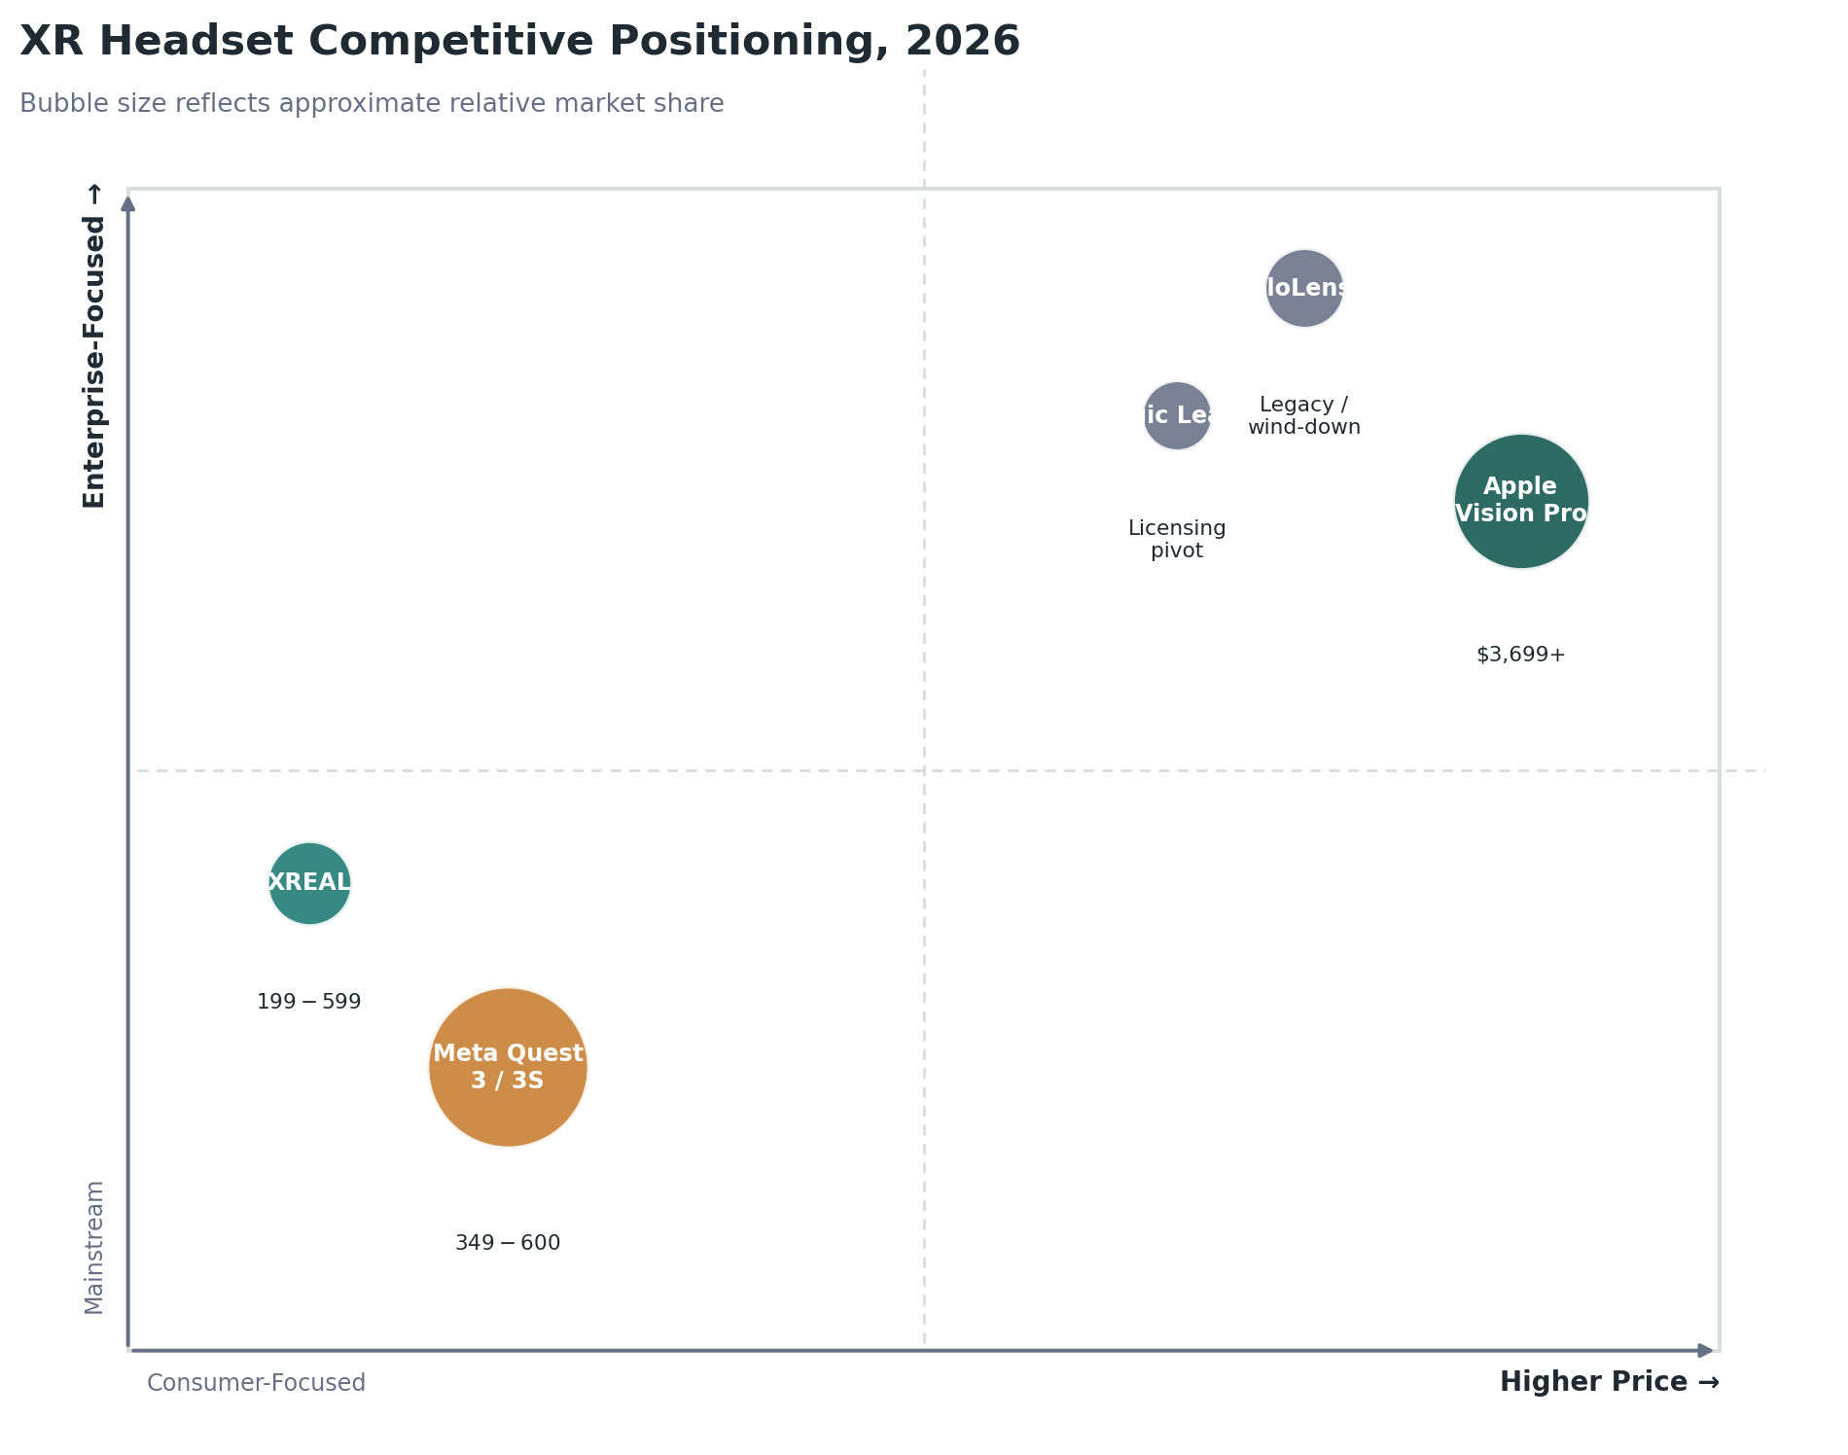
Figure 3. Approximate competitive positioning by price and consumer-versus-enterprise focus. Illustrative, not based on disclosed market-share data.
Dimension | Apple Vision Pro | Meta Quest 3 / 3S | Microsoft HoloLens 2 | Magic Leap 2 | XREAL
Starting Price (US) | $3,699 | $349.99 (3S) / $599.99 (3) | ~$3,500 (legacy stock) | ~$3,299 | ~$199-$599
Positioning | Premium spatial computer | Mainstream VR/MR headset | Discontinued enterprise AR | Enterprise AR (licensing pivot) | Portable AR display glasses
Primary Buyer | Prosumers, enterprises | Consumers, gamers | Legacy enterprise/defense | Healthcare, manufacturing | Consumers wanting a portable screen
Key Strength | Display quality, ecosystem, software polish | Price, installed base, content library | Mature enterprise deployments (legacy) | Optics IP, waveguide technology | Lightweight, affordable, simple
Key Weakness | Price, battery life, thin native app catalog | Lower display fidelity than Vision Pro | No future hardware roadmap | Financially dependent, small share | No standalone computing or MR
Market Trajectory | Enterprise-leaning; next headset paused | Volume leader; Quest 4 delayed to 2027-2028 | Wind-down through 2027 support | Shifting to technology licensing | Growing within AR glasses niche
Table 5. Competitive comparison across positioning, pricing, audience, strengths, weaknesses, and trajectory, compiled from company statements and independent reporting as of mid-2026.
Viewed together, the competitive set reveals an important structural point: Vision Pro's most direct historical rivals in enterprise AR, HoloLens and Magic Leap as pure hardware plays, have both retreated from the field, leaving Meta as the only other large, well-funded company still investing aggressively in mixed reality hardware. That leaves Apple in an unusual position: less crowded competitively at the high end than it appeared at launch, but still needing to prove that its enterprise and prosumer strategy can scale into a durable business on its own, without direct peers to validate the category's commercial viability the way multiple credible competitors might.

SWOT Analysis
Strengths | Weaknesses
Best-in-class display resolution and passthrough quality; deep integration with Mac, iPhone, and iCloud; strong brand trust and premium retail experience; mature enterprise APIs (Protected Content, device management); genuine differentiated use cases in training and design review | Price is roughly 7-8x the mainstream competitor; battery life limited to 2.5-3 hours; headset weight causes fatigue in extended sessions; thin native app catalog relative to iOS; unclear consumer mass-market path; no next-generation headset expected for at least two years

Opportunities | Threats
Enterprise and vertical-specific expansion (aviation, surgery, design); potential lower-cost consumer variant; component and battery technology maturing over time; Apple's reported smart glasses line could create a complementary product family; growing overall XR market through 2030 | Meta's dominant installed base and lower pricing; rising component costs industry-wide; smart glasses capturing consumer attention and investment away from headsets; slow developer investment in native visionOS apps; execution risk if Apple's leadership transition disrupts the spatial computing roadmap
Table 6. SWOT analysis of Apple Vision Pro as of mid-2026.
The dominant strategic tension in this SWOT is between Apple's clear technical and experiential strengths and a set of weaknesses and threats that are largely structural rather than easily fixed through incremental software updates. Battery life, weight, and price are hardware-economics problems that require real component and manufacturing breakthroughs, not marketing solutions, which is consistent with Apple's own decision to pause development on a successor rather than rush an incremental update.

Industry Use Cases
Vision Pro's clearest evidence of product-market fit comes not from broad consumer adoption but from a set of specific, well-documented vertical use cases. The examples below are drawn from publicly reported customer deployments and Apple's own case study materials.

Education
Universities and training institutions use Vision Pro for anatomy visualization, immersive language instruction, and remote lab demonstrations, though large-scale classroom deployment remains limited by cost; most education use cases today are pilot programs or single-institution initiatives rather than district- or system-wide rollouts.

Healthcare
Healthcare has emerged as one of Vision Pro's strongest verticals. Visage Imaging has built clinical decision-support tools on the platform, and SightMD has developed a cataract surgery training application, part of a broader medical pivot in which Vision Pro is used for surgical planning, medical education, and patient communication, leveraging its display fidelity for detailed 3D imaging review.

Manufacturing
Manufacturers use Vision Pro for design review, assembly-line visualization, and remote expert assistance, following a pattern earlier pioneered by HoloLens 2 in the same sector. Apple's enterprise APIs, including persistent windows and device management, support the kind of shared, repeatable factory-floor deployment this use case requires.

Architecture and Engineering
Architecture, engineering, and construction firms use Vision Pro to walk through full-scale 3D building models before construction begins, catching design conflicts earlier than 2D drawings or physical models allow. This mirrors Porsche's reported use of the device for automotive product design review at true scale.

Entertainment
Entertainment remains one of Vision Pro's most consumer-visible use cases, spanning immersive video content produced with partners such as Disney, spatial video capture and playback, and large-format virtual movie screens, an application central to Apple's travel and home-entertainment marketing.

Enterprise Collaboration
SAP's internal deployment of roughly one hundred units illustrates enterprise collaboration use cases: shared spatial meeting spaces, persistent virtual workspaces, and Persona-based video calls intended to make remote collaboration feel closer to in-person presence, though adoption at this scale remains rare among Apple's disclosed enterprise references.

Retail
Retail use cases include virtual showrooms, remote product configuration, and immersive brand experiences, though this remains one of the less mature verticals for Vision Pro relative to healthcare or design review, with fewer large, named retail deployments publicly documented as of mid-2026.

Customer Benefits
For the buyers who do adopt Vision Pro, the realized benefits are genuine rather than purely aspirational. Enterprise customers in training-intensive fields report measurable time savings, CAE's aviation training example being the most concrete public figure available. Design and engineering teams gain the ability to catch costly errors before physical prototyping. Individual professional users gain a private, high-quality, portable display that can replace a physical monitor setup while traveling. Frequent flyers and media consumers gain an immersive entertainment experience unmatched by any phone or tablet screen.
These benefits share a common pattern: they are strongest for buyers with a specific, recurring, high-value task that the device performs better than any available alternative, and weakest for buyers seeking general-purpose, everyday utility comparable to a phone or laptop. This pattern reinforces the audience-narrowing thesis that runs through this report's positioning and target audience sections.

Risks and Challenges
Vision Pro faces four interlocking risks. The first is the developer ecosystem gap: reporting drawing on Apple's own submission volumes suggests visionOS receives a very small number of native app submissions relative to iOS, and Apple made no major new push to incentivize native development at its 2026 developer conference. Without a denser native app catalog, the platform's everyday utility beyond its current core use cases will struggle to broaden.
The second is price elasticity in an unfavorable direction: rising memory and component costs industry-wide mean Apple's ambition of a lower-cost consumer headset, long rumored, faces a harder economic environment than it did at launch, potentially delaying the very product that could expand Vision Pro's addressable market. The third is category competition from smart glasses, which are capturing a larger share of consumer attention, investment, and unit growth than immersive mixed reality headsets, raising the possibility that the eventual mass-market form factor bypasses headsets altogether in favor of lighter, display-optional glasses.
The fourth risk is organizational: Apple's own reported pause on next-generation Vision Pro development, alongside a leadership transition as John Ternus takes over as CEO, introduces execution uncertainty about how committed Apple's next leadership generation will remain to the spatial computing roadmap Tim Cook championed. A prolonged product pause risks ceding further ground to Meta's installed base and to whichever company first ships a genuinely lightweight, affordable mixed reality product at scale.

Privacy and Security
Vision Pro's sensor array, cameras, eye tracking, and room-mapping LiDAR, raises privacy questions that are more pronounced than on a phone or laptop, both for the wearer and for bystanders captured incidentally by passthrough cameras. Apple's stated design approach processes eye-tracking data on-device and does not share raw gaze data with apps or Apple itself, disclosing only the end result of a selection gesture, a privacy architecture consistent with Apple's broader on-device processing philosophy across its product line.
For enterprise deployments, Apple has built out role-based Protected Content APIs and device management tools intended to satisfy the data governance requirements of regulated industries such as healthcare and defense-adjacent manufacturing, a necessary foundation for the clinical and industrial use cases described earlier in this report. Even so, mixed reality as a category raises unresolved bystander-consent questions, since passthrough cameras capture people who never opted into being recorded, an industry-wide policy question that extends well beyond Apple's own product decisions and remains an area regulators in multiple jurisdictions are actively studying.

Future Opportunities
Three plausible paths forward emerge from the evidence in this report. The first is a deliberate enterprise-first strategy, in which Apple leans further into training, healthcare, and design-review verticals, builds out enterprise sales and partner channels more aggressively, and treats consumer sales as a secondary benefit rather than the primary goal, effectively accepting Vision Pro's current trajectory and optimizing for it rather than fighting it.
The second is a lower-cost consumer variant, long rumored under names such as Vision Air, that would trade some display fidelity and compute power for a price point closer to 1,500 to 2,000 dollars, aiming to widen the addressable consumer base meaningfully. Rising memory costs make this path harder to execute profitably in the near term than it looked in 2024, but it remains the most direct route to consumer scale if component economics improve.
The third is convergence with Apple's reported smart glasses program, credibly described in industry reporting as display-less eyewear with cameras, microphones, and an AI assistant, expected as early as late 2026 or 2027. If Apple pursues a two-tier spatial computing family, glasses for all-day wearability and Vision Pro for high-fidelity immersive work, the two products could be positioned as complements rather than as sequential replacements, similar to how Apple Watch and iPhone coexist rather than compete.

Strategic Recommendations
Based on the analysis in this report, five recommendations follow for Apple's executive leadership.
- Formalize the enterprise-first strategy rather than treating it as a byproduct of consumer softness. Build a dedicated enterprise sales and solutions organization for Vision Pro, expand named vertical partnerships in aviation, healthcare, and manufacturing, and publish outcome data, training time reductions, error rate improvements, where customers allow it, to build a defensible body of proof beyond anecdote.
- Prioritize a lower-cost consumer variant once component costs stabilize, even if it requires trade-offs on display resolution or compute power, since price remains the single most cited barrier to broader consumer adoption across nearly every independent review referenced in this report.
- Invest directly in closing the native developer gap, potentially through expanded developer incentives, revenue guarantees for launch-vertical apps, or in-house development of category-defining productivity and creative apps that give third-party developers a reason to follow.
- Treat smart glasses and Vision Pro as a coordinated two-tier family rather than competing internal projects, with clear, differentiated marketing that explains which product serves which need, avoiding the customer confusion that has sometimes accompanied Apple's own multi-tier product lines in the past.
- Maintain price discipline and brand exclusivity in the near term rather than discounting, since the current buyer base is demonstrably price-inelastic; instead, expand value through AppleCare One-style bundling, financing options, and enterprise service contracts that reduce total cost of ownership without eroding the sticker price signal.

Frequently Asked Questions

1. Is Apple Vision Pro a virtual reality headset?
Not exactly. Apple markets it as a spatial computer that supports both fully immersive virtual environments and passthrough mixed reality, where the physical room remains visible with digital content layered on top. The distinction is more than marketing language, since the passthrough mode is the default and primary experience for most use cases.

2. How much does Apple Vision Pro cost in 2026?
As of the June 2026 price increase, the M5 Vision Pro starts at 3,699 dollars for 256GB, rising to 3,899 dollars for 512GB and 4,199 dollars for 1TB in the United States, before tax. Buyers who need vision correction may also need ZEISS Optical Inserts at additional cost.

3. Why is Vision Pro so much more expensive than Meta Quest?
The price gap reflects both higher-cost components, particularly dual micro-OLED displays and custom silicon, and different business models. Meta has historically subsidized Quest hardware to build a large installed base for its software and content ecosystem, a strategy Apple's margin-driven business model does not typically employ.

4. Who is actually buying Vision Pro?
Public reporting and independent case studies point to three buyer groups: affluent early adopters and existing Apple loyalists, creative and knowledge-work professionals using it as a productivity and display device, and enterprise buyers deploying it for training, design review, and healthcare applications. Apple does not disclose a breakdown of sales by segment.

5. Will there be a Vision Pro 2 or a cheaper Vision model?
Apple refreshed the original Vision Pro with an M5 chip in October 2025 rather than releasing a full second generation, and reporting through mid-2026 indicates active development on a successor headset is paused for at least two years while Apple reportedly prioritizes smart glasses. A lower-cost consumer variant has been rumored but not confirmed by Apple.

6. What happened to Microsoft HoloLens, Vision Pro's enterprise rival?
Microsoft ended HoloLens 2 production in 2024 and confirmed in 2025 that it will not build a HoloLens 3, shifting focus toward cloud and AI software while continuing limited security support for existing devices through 2027. This effectively removes Microsoft as a forward-looking hardware competitor in enterprise mixed reality.

7. Can I wear glasses or contacts with Vision Pro?
Vision Pro is designed to be used without glasses. Contact lens wearers can typically use the device directly, while glasses wearers generally need Apple's magnetically attached ZEISS Optical Inserts, determined through a series of vision questions during the ordering process.

8. What is Vision Pro's biggest limitation according to reviewers?
Battery life and weight are the two most consistently cited limitations. The external battery pack provides roughly two and a half to three hours of use per charge, and the headset's weight can cause fatigue during extended sessions, both of which reviewers frequently note limit all-day, everyday use.

9. Is Vision Pro primarily a gaming device?
No. Unlike Meta Quest, Apple has not positioned Vision Pro around gaming, and its native game catalog is comparatively limited. Apple markets it primarily around productivity, spatial video and entertainment, and, increasingly, enterprise applications rather than gaming.

10. What should a business consider before buying Vision Pro units for enterprise use?
Organizations should weigh Vision Pro's cost against the specific task it replaces, such as simulator time, physical prototyping, or in-person training, rather than against consumer headset pricing. They should also evaluate battery life and session length against their actual use pattern, confirm device management and Protected Content API support for regulated data, and pilot with a small deployment before committing to fleet-scale purchases.

Key Takeaways
- Vision Pro is best understood as a premium, enterprise-leaning platform bet, not a mass-market consumer product, and Apple's own 2025-2026 decisions increasingly confirm this positioning.
- Its unique value proposition, display fidelity, natural input, and ecosystem integration, is real and defensible, but it is realized fully only by a narrow, well-defined set of buyers.
- Two of Vision Pro's most credible enterprise rivals, Microsoft HoloLens and, to a lesser extent, Magic Leap, have stepped back from hardware competition, leaving Meta as the primary remaining large-scale rival, but at a fundamentally different price tier and audience.
- Battery life, weight, price, and a thin native developer ecosystem remain the platform's core structural constraints, and none of them has a quick fix.
- Apple's most promising near-term path is to formalize, rather than downplay, an enterprise-first go-to-market strategy while it waits for component economics and battery technology to support a genuinely lower-cost consumer variant.

Conclusion
Apple Vision Pro is neither the mainstream computing revolution its 2024 launch narrative implied nor the failure some early commentary suggested. It is a technically impressive, strategically patient bet on a category still in its early innings, one where Apple has chosen to prioritize experience quality and brand integrity over volume and speed. The device has found real, defensible value in specific enterprise and prosumer contexts even as its path to mass-market consumer adoption remains unresolved.
The most useful lens for evaluating Vision Pro going forward is not whether it becomes as ubiquitous as the iPhone, a bar it was likely never going to clear in its first generation, but whether Apple can convert its early enterprise and prosumer traction into a durable, expanding business while component costs and battery technology mature enough to support a genuinely mass-market successor. The next eighteen to twenty-four months, spanning the reported pause in headset development and the arrival of Apple's smart glasses line, will likely determine which of the paths outlined in this report Apple actually chooses to pursue.

References
This report draws on official Apple documentation and public reporting from reputable technology and business press, current as of July 2026. Individual figures and claims are attributed contextually throughout the report; sources consulted include:
- Apple Newsroom and Apple product pages (apple.com), including Vision Pro specifications, pricing, and feature announcements.
- Apple Vision Pro buying and support documentation, including ZEISS Optical Inserts and AppleCare guidance (apple.com/shop/buy-vision).
- MacRumors, coverage of Apple's June 2026 pricing changes and the Vision Pro product roundup.
- UploadVR, reporting on Apple's June 2026 price increases and Microsoft's HoloLens 2 discontinuation.
- VR.org, analysis of Vision Pro's enterprise positioning following the June 2026 price increase, and ongoing Meta Quest 4 tracking coverage.
- Next Reality, coverage of visionOS 27, IDC market data on mixed reality and smart glasses shipments, and Vision Pro's competitive standing.
- Reality Atlas and BusinessStats, independent pricing and value analyses of Vision Pro through 2026.
- Microsoft Learn and Microsoft Q&A, official HoloLens 2 lifecycle and release note documentation.
- SiliconANGLE and Road to VR, reporting on Magic Leap's strategic pivot toward technology licensing and its Google partnership.
- Moor Insights & Strategy, independent analyst commentary on the enterprise AR competitive landscape.
Where a specific figure, such as Vision Pro unit sales or detailed profitability, is not publicly disclosed by Apple, this report states that explicitly rather than estimating it.

Professional Reflection
Analyzing Apple Vision Pro end to end surfaces a few strategic lessons that extend well beyond this one product. The first is that category-defining hardware and mass-market adoption are not the same milestone, and treating them as one can lead to premature verdicts. Vision Pro was widely declared a disappointment within months of launch by commentators comparing it to the iPhone's trajectory, yet judged against Apple's own apparent strategy, establishing a technical foundation, a developer platform, and credible enterprise traction before pursuing volume, the product looks considerably more deliberate than that early narrative suggested.
The second lesson concerns positioning discipline. Apple's decision to call Vision Pro a spatial computer rather than a headset was not just marketing language; it reset the comparison set Apple would be judged against, and the company has largely stayed disciplined about that framing even as public and analyst commentary kept pulling the conversation back toward gaming and VR headset comparisons. Good positioning requires the patience to hold a category redefinition even when the market is slow to adopt the new frame.
The third lesson is about reading pricing decisions as strategic signals rather than isolated financial moves. Apple's choice to hold price steady through the October 2025 M5 refresh, then raise it only when forced by industry-wide component costs in June 2026, together with analysts' observation that the increase had essentially no demand impact, is a clear tell about who the real customer has become. Product marketers should treat pricing stability or change as a data point about audience and elasticity, not merely as a revenue lever.
Finally, this analysis reinforced that customer adoption challenges in genuinely new categories are rarely solved by a single feature update. Vision Pro's core constraints, battery life, weight, price, and developer density, are structural and interdependent, and no single visionOS release has resolved any of them. The long-term opportunity for Apple, and the broader lesson for any team building category-defining hardware, is that patience, a credible enterprise beachhead, and honest acknowledgment of a product's real limitations are more valuable in the first several years than premature claims of mass-market success. This is not a personal experience but an analytical conclusion drawn from the publicly available record examined throughout this report.

